
Project Report
Object Oriented Programming
Department of Computer Science
Project Name:
EXCEPTION HANDLING HEADER FILE

Submitted to:
Dr. Mariam Nousheen
Submitted by:
Fatima Nadeem (23251101028)
Fabiya Noor (23251101023)
Wajeeha Mehmood (23251101113)

1. Introduction:
- Brief Introduction:
The Exception Handler .h header file provides a collection of custom exception classes and functions for handling several types of exceptions in C++. It includes functionalities for user interruption, overflow/underflow, division by zero, invalid parameter exceptions, file not found, index out of bounds, null pointer, data conversion, and default exceptions. The header file also defines functions for input validation, file handling, and signal handling.
When you're writing a program, you often need to handle situations where things don't go as planned. A user types in the incorrect information, or a file can't be found. ExceptionHandler.h helps you handle these situations by providing clear messages and organized ways to deal with errors.
With ExceptionHandler.h, you don't have to worry about writing complex code to handle errors. Instead, you can use ready-made functions and classes that simplify the process. It is like having a toolkit full of useful tools for fixing problems in your code.
This header file is split into various parts, each focusing on a specific aspect of error handling. Whether you need to deal with signals from the operating system, validate user input, or work with files, ExceptionHandler.h has you covered.

Scope:
ExceptionHandler.h covers a range of error management tasks in C++ programs. It provides developers with a versatile set of tools to handle different types of errors effectively.
By allowing the creation of custom error messages, ExceptionHandler.h helps developers explain errors clearly. It also assists in validating user inputs and managing files correctly. This makes it a dependable solution for dealing with errors in various parts of a program.
- Problem statement:
Programs frequently encounter errors, incorrect user inputs, and file handling issues, which can lead to crashes, poor user experiences, and unreliable software.
- Solution:
The solution entails creating a comprehensive header file, ExceptionHandler.h, which encapsulates custom exception classes for various error scenarios, input validation functions, file handling functions, and signal handling mechanisms. By utilizing this header file, developers can efficiently manage errors, validate inputs, handle files, and manage signals, thereby improving program reliability and user experience.
To achieve this solution, The project achieved its goals by defining custom exception classes derived from a base “ CustomException ” class. Each exception class encapsulates specific error messages and functionalities. Additionally, it provides functions to handle exceptions using try-catch blocks and signal handlers.
Each component was carefully crafted to address specific error scenarios and ensure robust error management within C++ programs.

Objective:
The main goal of creating this header file, ExceptionHandler.h, is to offer a strong and adaptable way to deal with errors in C++ programs. By bundling together, a wide range of error-handling tools and custom exception classes, the aim is to give developers the means to effectively handle and resolve errors that pop up while their programs run. With a focus on simplicity and flexibility, this project aims to make it easier for developers to ensure their C++ applications run smoothly, are easier to maintain, and have fewer bugs. Through straightforward documentation and user-friendly features, the aim is to simplify the process of handling errors, making it simpler for developers to build reliable and robust software.

Project Architecture
Base Class Module:
This class serves as the parent class for all specific exception classes and defines essential attributes and methods, such as setting and displaying error messages. It encapsulates common behavior shared among derived exception classes, promoting code reusability and abstraction.
Derived Classes Modules:
- Division By Zero Exception Module:
Handles exceptions related to division by zero, ensuring proper error reporting and graceful handling of division operations.
- Array Out of Bounds Exception Module:
Handles exceptions related to accessing array elements outside the defined bounds, ensuring proper error reporting and graceful handling of out-of-range accesses.
- Null Pointer Exception Module:
Handles exceptions related to dereferencing null pointers, ensuring proper error reporting and graceful handling of null pointer accesses.
- Invalid Exception Module:
Handles exceptions related to invalid input, including validation of positive/negative numbers, data type conversion, numeric strings, and non-empty strings.
- File Exception Module:
Handles exceptions related to file operations, including validation of file existence, permissions for appending, and write access.
- Underflow Exception Module:
Handles exceptions related to arithmetic underflow, ensuring proper error reporting and graceful handling of underflow conditions.
- Overflow Exception Module:
Handles exceptions related to arithmetic overflow, ensuring proper error reporting and graceful handling of overflow conditions.
- User Interrupt Exception Module:
Handles exceptions related to user interruptions, such as SIGINT signals, ensuring proper handling and graceful exit of the program.
- Data Conversion Exception Module:
Handles exceptions related to data conversion, such as converting hexadecimal and octal strings to integers, ensuring proper error reporting and handling of conversion errors.
10) Default Exception Module:
Handles any unexpected or general exceptions that are not specifically covered by other modules. It ensures proper error reporting and graceful handling of unforeseen errors, maintaining program stability and enhancing the user experience.

2. Background Literature
- Similar Software:

      - Cpp -utility /exceptions
      - Catch2
      - Google Test (googletest)
      - CppUnit
      - QTestLib
      - UnitTest++

- Comparative Analysis:
There are several libraries and header files like ExceptionHandler.h that offer functionalities for error handling and exception management in C++ programs. These libraries typically provide custom exception classes, input validation functions, and file handling utilities. However, what sets ExceptionHandler.h apart is its simplicity and ease of use. Unlike some complex libraries, ExceptionHandler.h offers straightforward functions and classes that are easy to understand and integrate into C++ projects. Additionally, ExceptionHandler.h focuses on providing essential error handling features without unnecessary complexity, making it suitable for students and beginners learning about error management in C++.

3. CLASS DIAGRAM

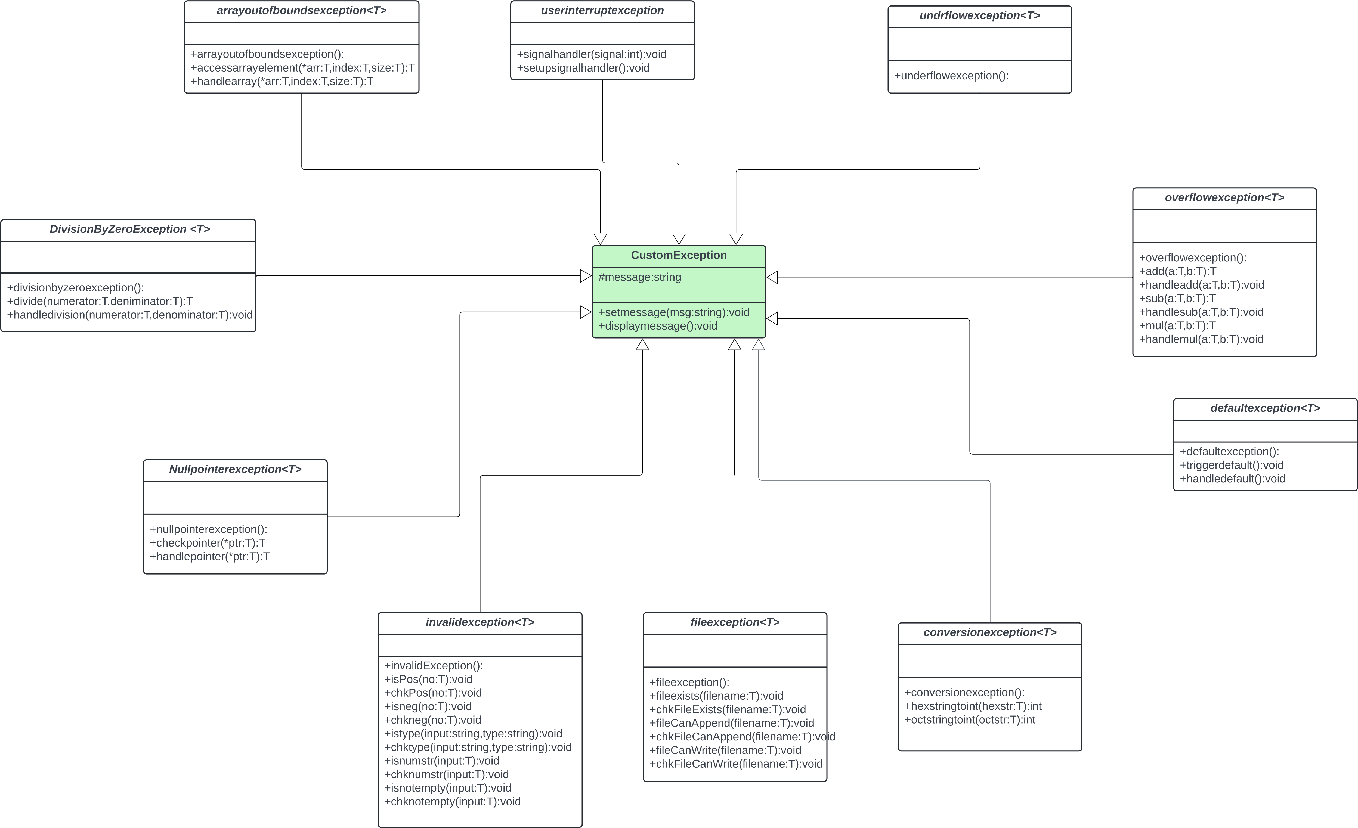

4. ALGORITHM AND CODE
1. Start with Header Guard
Use header guards to prevent multiple inclusions of the header file.
2. Include Necessary Libraries:
Include standard libraries such as
<iostream>
<string>
<stdexcept>
<sstream>
<fstream>
<atomic>
<csignal>
<windows.h>
<limits>
3. Define a Base Exception Class:
Create a base class named “Custom Exception” which will contain a string to store error messages.
Implement methods to set and display the error message.
4. Define Derived Exception Classes:
Create various derived exception classes for different types of exceptions:
- DivisionByZeroException
- arrayoutofboundsexception
- NullPointerException
- UnderflowException
- OverflowException
- UserInterruptException
- invalidException
- fileException
- DefaultException
- ConversionException
Each derived class should inherit from the `custom` base class.
5. Implement DivisionByZeroException Class:
- Define methods to perform division operations and handle division by zero errors.
- Provide methods for division and error handling.
6. Implement arrayoutofboundsexception Class:
- Define methods to handle array access and check if the access is out-of-bounds.
- Provide methods to access array elements safely and handle out-of-bounds errors.
7. Implement NullPointerException Class:
- Define methods to check for null pointers and handle dereferencing null pointers.
- Provide methods to check pointers and handle null pointer exceptions.
8. Implement Under flow Exception and Overflow Exception Classes:
- Define methods to handle arithmetic underflow and overflow situations.
- Provide methods for addition, subtraction, and multiplication, and their corresponding error handlers.
9. Implement User Interrupt Exception Class:
- Define methods to handle user interruptions (e.g., Ctrl+C).
- Provide methods to set up signal handlers and handle the interrupt signal.
10. Implement invalidException Class:
- Define methods to validate various types of inputs:
- Check if a number is positive or negative.
- Check if a string can be converted to a specified data type.
- Check if a string contains only numeric characters.
- Check if a string is not empty.
- Provide methods for validation and error handling for each type of input.
11. Implement fileException Class:
- Define methods to handle file-related exceptions:
- Check if a file exists.
- Check if a file can be appended.
- Check if a file can be written.
- Provide methods for file validation and error handling.
12. Implement Default Exception Class:
- Define methods to handle a default exception scenario.
- Provide methods to trigger and handle a default exception.

13. Implement ConversionException Class:
- Define methods to handle data conversion errors, such as converting hexadecimal and octal strings to integers.
- Provide methods for conversion and error handling.
14. Implement Helper Functions:
- For each exception class, provide helper functions to simplify access to class methods.
- These helper functions should create an instance of the exception class and call its methods.
15. Close Header Guards:
- End the header file with the closing of the header guard.

Algorithm FOR Division by Zero Exception:
• Define Exception Class:
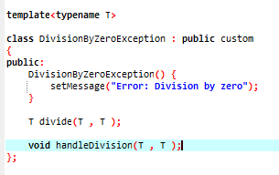
- Begin by defining a template class DivisionByZeroException derived from the base class custom.
- Provide a constructor to initialize the error message.
• Define the divide Function:
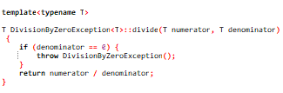
- Declare a template member function divide within the DivisionByZeroException class, which takes two parameters numerator and denominator.
• Implement the divide Function:
- Define the divide function outside the class.
- Check if the denominator is zero.
- If it is zero, throw a DivisionByZeroException.
- Otherwise, perform the division and return the result.
• Define the handle Division Function:
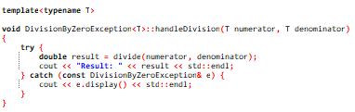
- Declare another template member function handleDivision within the DivisionByZeroException class.
- This function will be used to handle the division operation and catch any exceptions thrown.
• Implement the handleDivision Function:
- Define the handleDivision function outside the class.
- Inside the function, call the divide function.
- Use a try-catch block to catch any DivisionByZeroException.
- If an exception is caught, display the error message using display function inherited from the base class.
• Define the Wrapper Function:
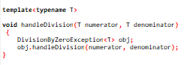
- Finally, define another function handleDivision outside the class.
- This function will be used to access the handleDivision member function through an object of the DivisionByZeroException class.
Algorithm For Array out of bound exception
• Define Exception Class:
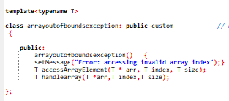
- Declare a templated class arrayoutofboundsexception derived from a base class custom which will serve as the base class for custom exceptions.
• Constructor:
- Define a constructor for the arrayoutofboundsexception class.
- Inside the constructor, set an error message indicating that an invalid array index has been accessed.
• Define Member Functions:
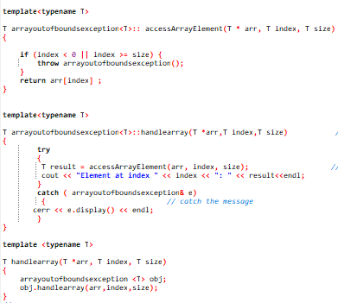
- Define two member functions accessArrayElement and handlearray.
• Define Member Function accessArrayElement:
- This function takes an array arr, an index index, and the size of the array size as parameters.
- Check if the index is out of bounds (i.e., less than 0 or greater than or equal to the size of the array).
- If the index is out of bounds, throw an instance of arrayoutofboundsexception.
- Otherwise, return the element at the specified index in the array.
• Define Member Function handlearray:
- This function takes an array arr, an index index, and the size of the array size as parameters.
- Inside a try block, call accessArrayElement to access the array element at the specified index.
- If an exception of type arrayoutofboundsexception is caught, display the error message using the display function (which is not provided in the code).
- Note: display function is not implemented in the provided code. You may need to add it or use a different method to access the error message
• Define Function handlearray:
- Define a function named handlearray.
- This function is templated and takes an array arr, an index index, and the size of the array size as parameters.
- Create an instance of arrayoutofboundsexception class.
- Call the handlearray member function of the arrayoutofboundsexception object.

Algorithm For Null Pointer Exception
• Define Exception Class:
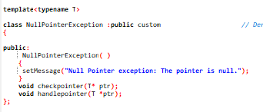
- Define a class NullPointerException derived from a base class custom which will serve as the base class for custom exceptions.
• Constructor:
- Define a constructor for the NullPointerException class.
- Inside the constructor, set an error message indicating that a null pointer has been dereferenced.
• Define Member Functions:
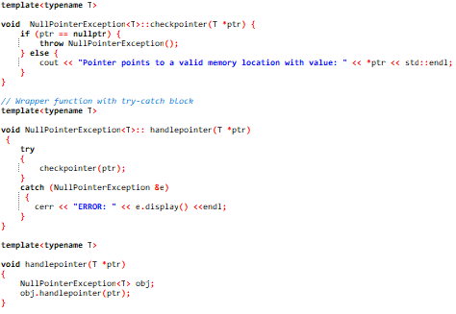
- Define two member functions: checkpointer and handlepointer.
• Define Member Function checkpointer:
- Define the checkpointer member function.
- This function takes a pointer ptr as a parameter.
- Check if the pointer is nullptr.
- If the pointer is nullptr, throw an instance of NullPointerException.
- Otherwise, print the value pointed to by the pointer.
• Define Member Function handlepointer:
- This function takes a pointer ptr as a parameter.
- Inside a try block, call checkpointer to check if the pointer is null.
- If an exception of type NullPointerException is caught, display the error message using the display function (which is not provided in the code).
- Note: display function is not implemented in the provided code. You may need to add it or use a different method to access the error message.
• Define Function handlepointer:
- This function is templated and takes a pointer ptr as a parameter.
- Create an instance of NullPointerException class.
- Call the handlepointer member function of the NullPointerException object.

Algorithm for Underflow and overflow

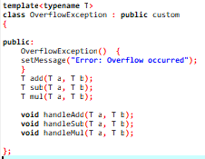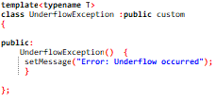
• Define Custom Exceptions:
- OverflowException and UnderflowException classes inherit from a base class custom.
- Each exception sets a specific error message in its constructor and has a display() method to return the message.
Arithmetic Operations with Overflow/Underflow Checks:
- Addition (add function):
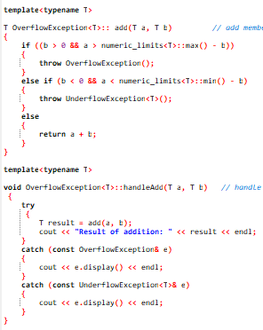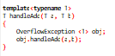
  - Check for overflow: if b > 0 and a > numeric_limits<T>::max() - b, throw OverflowException.
  - Check for underflow: if b < 0 and a < numeric_limits<T>::min() - b, throw UnderflowException.
  - Otherwise, return a + b.
- Subtraction (sub function):
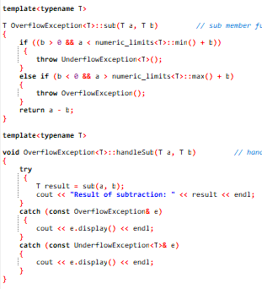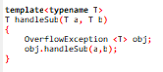
- Check for underflow: if b > 0 and a < numeric_limits<T>::min() + b, throw UnderflowException.
- Check for overflow: if b < 0 and a > numeric_limits<T>::max() + b, throw OverflowException.
- Otherwise, return a - b.
- Multiplication (mul function):
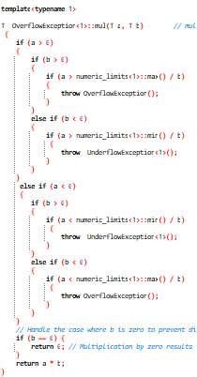
  - Check for overflow or underflow based on the signs of a and b using appropriate limits.
  - Special case: if b == 0, return 0 (multiplication by zero).
  - Otherwise, return a * b.
Handling Operations with Exception Management:
- Addition (handleAdd function):
  - Try to perform add(a, b).
  - Catch and display OverflowException or UnderflowException.

- Subtraction (handleSub function):
  - Try to perform sub(a, b).
  - Catch and display OverflowException or UnderflowException.

- Multiplication (handleMul function):
  - Try to perform mul(a, b).
  - Catch and display OverflowException or UnderflowException.
Algorithm for Interrupt Exception

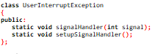
Global Atomic Flag:
- extern atomic<bool> interrupted;: Declare an external atomic boolean flag named interrupted to indicate if an interruption (e.g., SIGINT) has occurred.
Signal Handler Function:
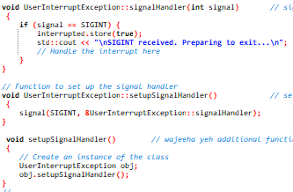
Signal handler function:
- Check if the signal received is SIGINT.
- If SIGINT is received:
- Set the interrupted flag to true.
- Sleep for 2000 milliseconds (2 seconds).
- Print a message indicating that SIGINT was received and the program is preparing to exit.
Setting Up the Signal Handler:
Set up Signal Handler function:
- Use the signal function to associate SIGINT with the signal Handler function, so that the custom signal handler is invoked when SIGINT is received.

Algorithm for Invalid Input Exceptions
• Create Class invalid Exception:
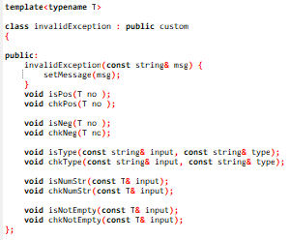
- Inherit from the base class custom.
- Define a constructor that takes a string message and sets it using setMessage.
• Declare Member Functions:
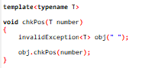
- isPos(T no): Checks if a number is positive.
- chkPos(T no): Validates if a number is positive and handles exceptions.
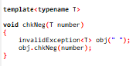

- isNeg(T no): Checks if a number is negative.
- chkNeg(T no): Validates if a number is negative and handles exceptions.
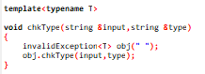

- isType(const string& input, const string& type): Checks if a string can be converted to the specified data type.
- chkType(const string& input, const string& type): Validates data type conversion and handles exceptions.
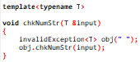
- isNumStr(const T& input): Checks if a string contains only digits.

- chkNumStr(const T& input): Validates numeric string and handles exceptions.
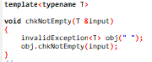
- isNotEmpty(const T& input): Checks if a string is not empty.

- chkNotEmpty(const T& input): Validates if a string is not empty and handles exceptions.
• Implement Member Functions
Check if a Number is Positive (isPos):
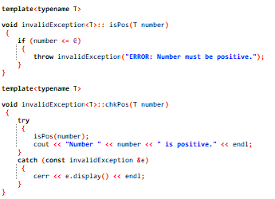
- If number is less than or equal to zero, throw invalidException with the message "ERROR: Number must be positive."
Handle Positive Number Validation (chkPos):
- Use a try block to call isPos(number).
- Print a success message if no exception is thrown.
- Catch invalidException and display the error message.
Check if a Number is Negative (isNeg):
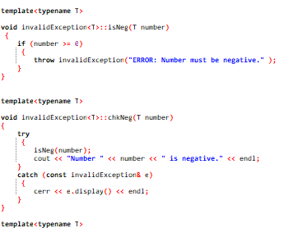
- If number is greater than or equal to zero, throw invalidException with the message "ERROR: Number must be negative."
Handle Negative Number Validation (chkNeg):
- Use a try block to call isNeg(number).
- Print a success message if no exception is thrown.
- Catch invalidException and display the error message.
Check Data Type Conversion (isType):
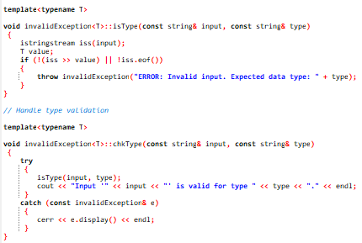
  - Use istringstream to attempt converting input to the type T.
  - If the conversion fails or if the entire string is not consumed, throw invalidException with the message "ERROR: Invalid input. Expected data type: " followed by type.
Handle Data Type Validation (chkType):
  - Use a try block to call isType(input, type).
  - Print a success message if no exception is thrown.
  - Catch invalidException and display the error message.
Check if a String Contains Only Digits (isNumStr):
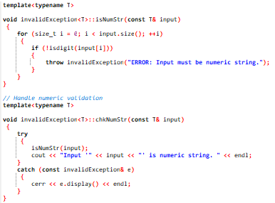
- iterate over each character in input.
- If any character is not a digit, throw invalidException with the message "ERROR: Input must be numeric string."
Handle Numeric String Validation (chkNumStr):
- Use a try block to call isNumStr(input).
- Print a success message if no exception is thrown.
- Catch invalidException and display the error message.
Check if a String is Not Empty (isNotEmpty):
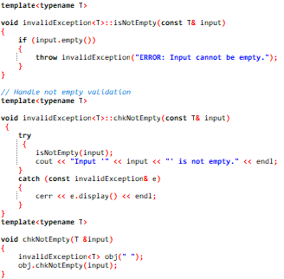
- If input is empty, throw invalidException with the message "ERROR: Input cannot be empty."
Handle Non-Empty String Validation (chkNotEmpty):
- Use a try block to call isNotEmpty(input).
- Print a success message if no exception is thrown.
- Catch invalidException and display the error message.

Define Wrapper Functions for Easy Validation
- Wrapper Function for Positive Number Validation (chkPos):
  - Create an instance of invalid Exception and call chkPos(number).
- Wrapper Function for Negative Number Validation (chkNeg):
  - Create an instance of invalid Exception and call chkNeg(number).
- Wrapper Function for Data Type Validation (chkType):
  - Create an instance of invalid Exception and call chkType(input, type).
- Wrapper Function for Numeric String Validation (chkNumStr):
  - Create an instance of invalid Exception and call chkNumStr(input).
- Wrapper Function for Non-Empty String Validation (chkNotEmpty):
  - Create an instance of invalid Exception and call chkNotEmpty(input).

Algorithm for File Handling Exceptions:
• Define Custom Exception Class:
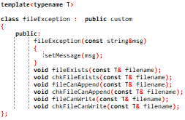
- Define a templated class fileException that inherits from a base class custom.
- The class has a constructor that sets an error message using the setMessage method.
• Member Functions:
- Declare several member functions to check different file conditions:
  - fileExists: Checks if a file exists.
  - chkFileExists: Wrapper function to handle fileExists and catch exceptions.
  - fileCanAppend: Checks if a file can be opened for appending.
  - chkFileCanAppend: Wrapper function to handle fileCanAppend and catch exceptions.
  - fileCanWrite: Checks if a file can be opened for writing.
  - chkFileCanWrite: Wrapper function to handle fileCanWrite and catch exceptions.

• Implement File Existence Check:
fileExists Function:
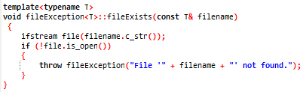
- Open the file using ifstream with the given filename.
- If the file cannot be opened, throw a fileException with the message "File '<filename>' not found."
chkFileExists Function:
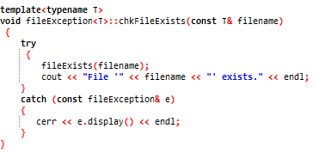
- Use a try block to call fileExists.
- If no exception is thrown, print "File '<filename>' exists."
- If an exception is caught, print the error message using e.display().
chkFileExists Wrapper Function:
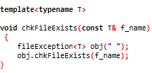
- Define a non-member templated function chkFileExists that creates an instance of fileException and calls chkFileExists on it.

• Implement File Append Check
fileCanAppend Function:
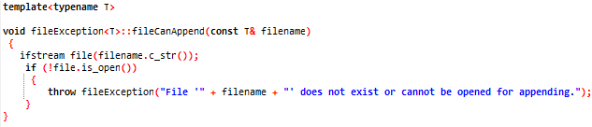
- Open the file using ifstream with the given filename.
- If the file cannot be opened, throw a fileException with the message "File '<filename>' does not exist or cannot be opened for appending."
chkFileCanAppend Function:
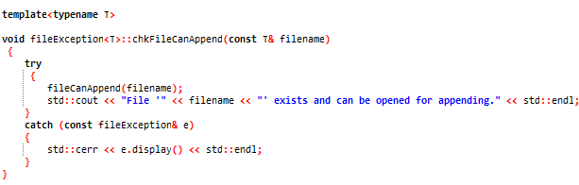
- Use a try block to call fileCanAppend.
- If no exception is thrown, print "File '<filename>' exists and can be opened for appending."
- If an exception is caught, print the error message using e.display().
chkFileCanAppend Wrapper Function:
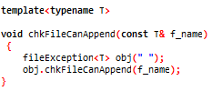
- Define a non-member templated function chkFileCanAppend that creates an instance of fileException and calls chkFileCanAppend on it.

• Implement File Write Check
fileCanWrite Function:
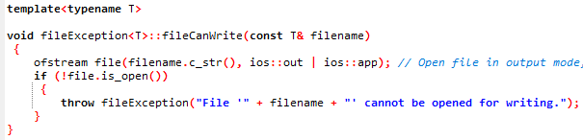
- Open the file using ofstream in output and append mode with the given filename.
- If the file cannot be opened, throw a fileException with the message "File '<filename>' cannot be opened for writing."
chkFileCanWrite Function:
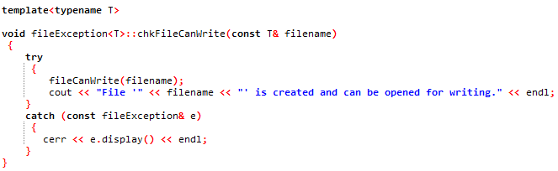
- Use a try block to call fileCanWrite.
- If no exception is thrown, print "File '<filename>' is created and can be opened for writing."
- If an exception is caught, print the error message using e.display().
chkFileCanWrite Wrapper Function:
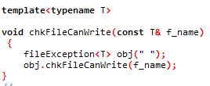
- Define a non-member templated function chkFileCanWrite that creates an instance of fileException and calls chkFileCanWrite on it.

Algorithm for Data Conversion Exceptions:

• Define Custom Exception Class:
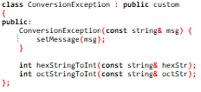
- The ConversionException class is defined, derived from the base class custom.
- The constructor initializes the error message using the provided message.
• Conversion Functions:
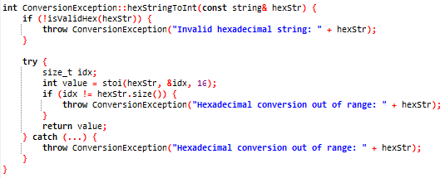
- hexStringToInt and octStringToInt are defined to convert hexadecimal and octal strings to integers, respectively.
- Each function checks the validity of the input string and throws a ConversionException if the string is invalid or if the conversion result is out of range.
- Validation Functions:
- isValidHex and isValidOct are utility functions to check if a hexadecimal or octal string is valid, respectively.
- These functions iterate over each character in the string and check if it matches the expected characters for hexadecimal or octal representation.
- Error Handling in Conversion Functions:
- Inside the conversion functions (hexStringToInt and octStringToInt), exceptions are caught and rethrown as ConversionException with appropriate error messages.
- Usage Functions:
- testHexStringToInt and testOctStringToInt are provided as wrapper functions to test the conversion functions.
- These functions create an instance of ConversionException and call the corresponding conversion function, catching any thrown exceptions and displaying the error messages.
Algorithm for Default Exception:
• Define Class DefaultException:
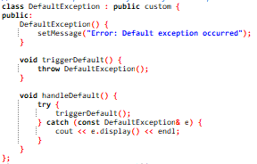
• Inheritance: Inherit from the base class custom.
• Constructor: Create a constructor that calls set Message with the string "Error: Default exception occurred".
• Methods:
Trigger Default: Throws an instance of Default Exception.
Handle Default: Uses a try block to call trigger Default
Uses a catch block to catch exceptions of type Default Exception.
Print the exception message using cout and the display method.
• Define Function handle Default:
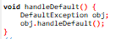
-Create an instance of Default Exception.
-Call the handle Default method on the created instance.

Detailed Steps:
- Constructor Execution:
- The DefaultException constructor sets the message to "Error: Default exception occurred".
- triggerDefault Method:
- The triggerDefault method throws an instance of Default Exception.
- Handle Default Method:
- The handle Default method includes a try-catch block:
- The try block attempts to execute trigger Default.
- When trigger Default throws Default Exception, control is transferred to the catch block.
- The catch block catches the thrown Default Exception instance.
- The catch block then calls the display method on the caught exception to get the message.
- Finally, it prints the message to the console

5. Limitations:
While ExceptionHandler.h offers an array of tools for managing exceptions in C++ programs, it does have some limitations. For instance, it primarily focuses on handling exceptions related to arithmetic operations, file management, and user input validation. However, it may not cover all potential error scenarios encountered in complex software systems. Additionally, the header file relies heavily on try-catch blocks for error handling, which could lead to code duplication if similar error-handling logic is needed across multiple parts of a program. Furthermore, while ExceptionHandler.h offers valuable support for common error situations, developers should be aware of its limitations and be prepared to augment it with custom error-handling strategies when necessary.
6. Future Enhancements:
Future enhancements for the ExceptionHandler.h header file include expanding the range of exception classes to cover a broader spectrum of error scenarios, improving support for handling asynchronous exceptions and multithreading, enhancing integration with existing C++ libraries to facilitate seamless error management, implementing better cross-platform compatibility by reducing reliance on platform-specific functions, introducing automated testing frameworks for ensuring robustness and reliability, offering comprehensive documentation and tutorials for easier adoption by developers, and integrating with logging frameworks to enable better tracking and analysis of error occurrences.
7. CONCLUSION:
The “ExceptionHandler.h” header file provides a comprehensive suite of custom exception classes and functions designed to manage a wide range of errors in C++ programs effectively. It includes specialized classes for handling common exceptions such as division by zero, invalid array access, null pointers, arithmetic overflow and underflow, user interruptions, and file-related errors. Additionally, it offers robust input validation and data conversion functions, ensuring developers can manage errors with clear messages and organized methods, improving the reliability and maintainability of their code.
8. USER INTERFACE
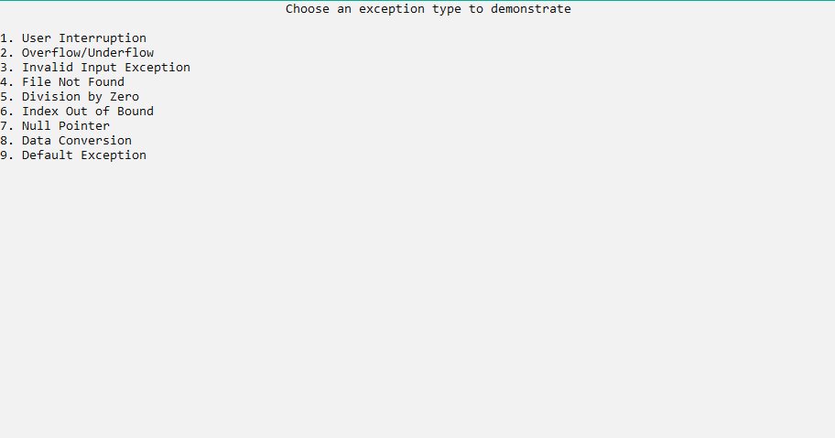
Main menu:

USER INTERRUPTION EXCEPTION:
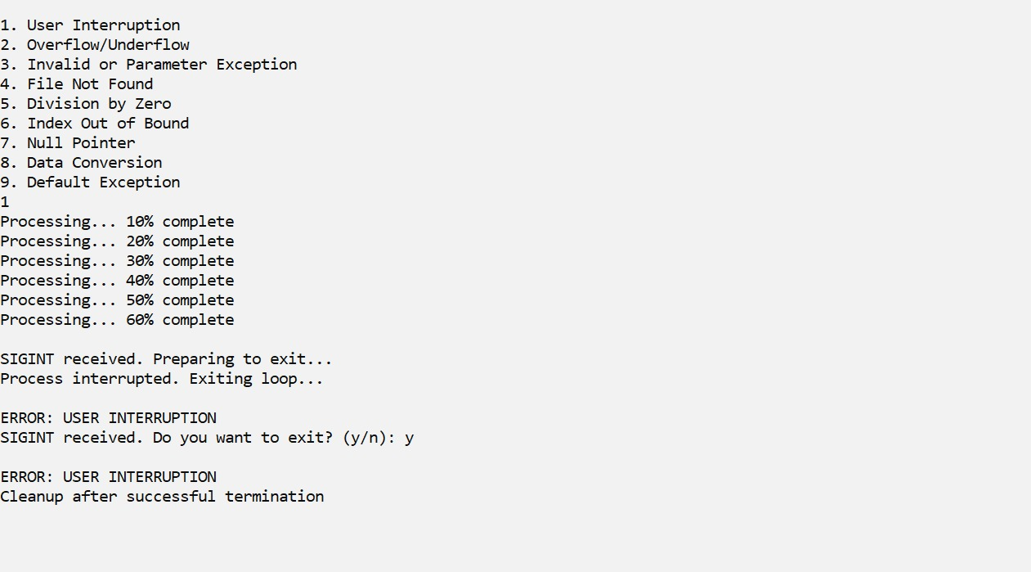

UNDERFLOW AND OVERFLOW EXCEPTION.
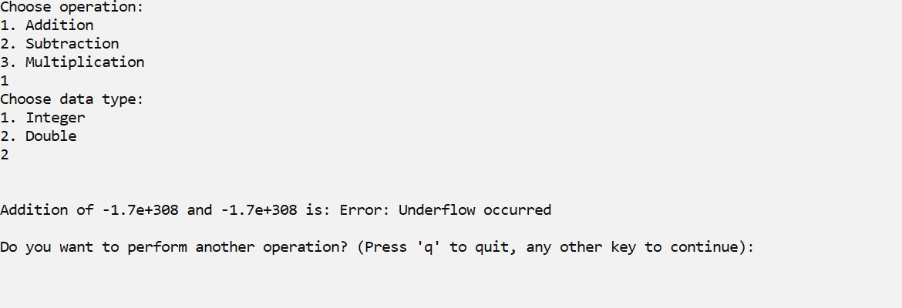
Addition:

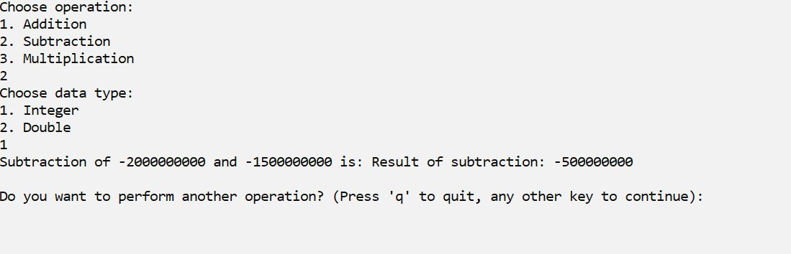
Subtraction:

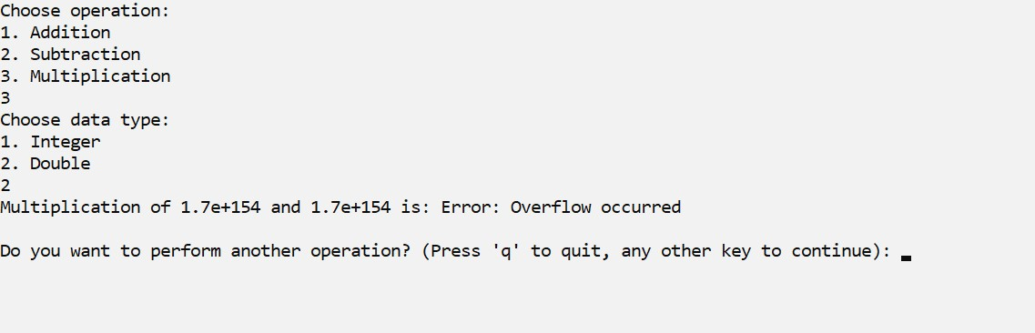
Multiplication:

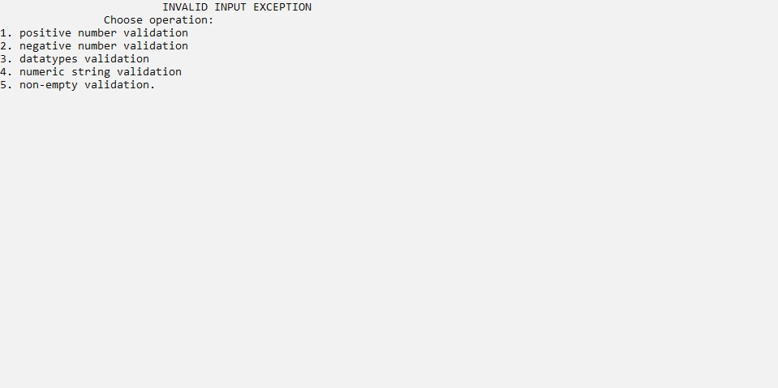
INVALID INPUT EXCEPTION

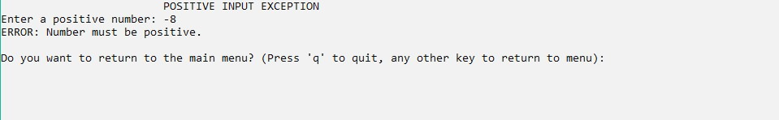
Positive Input Exception:

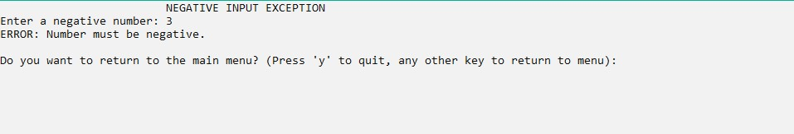
Negative Input Exception:

Integer Input Exception:
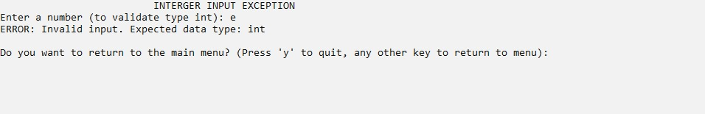
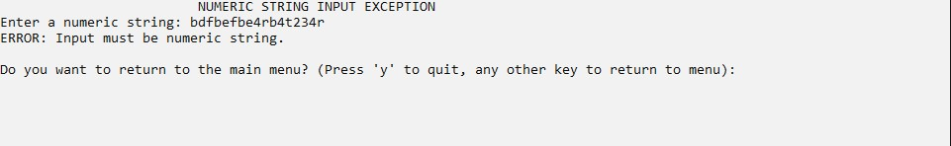
Numeric String Exception:

Non-Empty String Exception:

FILE HANDLING EXCEPTIONS
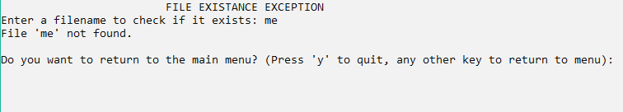
File Not Found Exception:

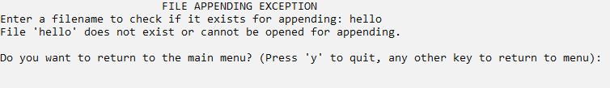
File Appending Exception:
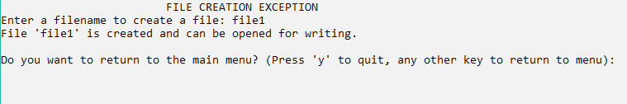
File Creation Exception:

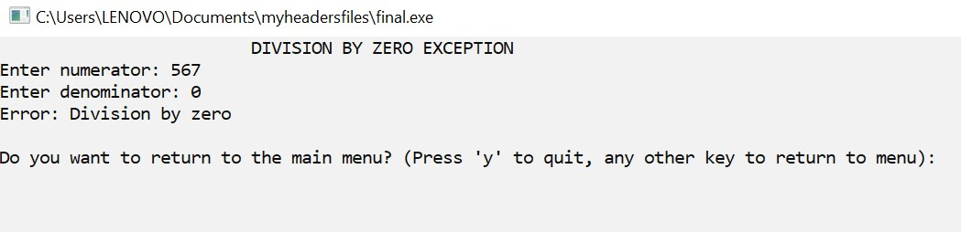
DIVISION BY ZERO EXCEPTION:

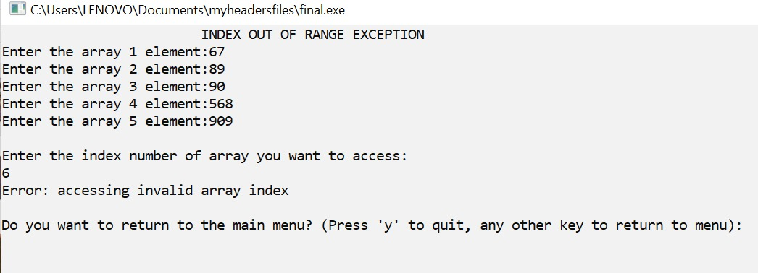
INDEX OUT OF BOUND

NULL POINTER EXCEPTION:
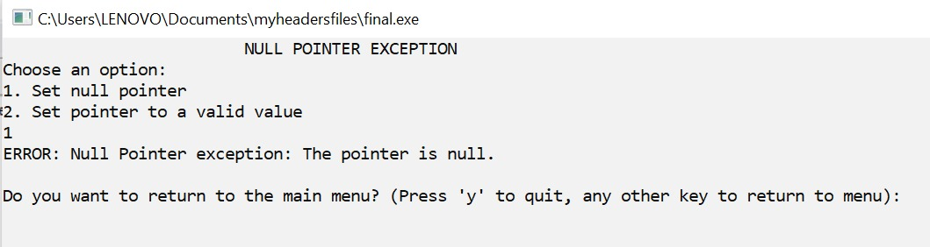
User trying to dereference null pointer:

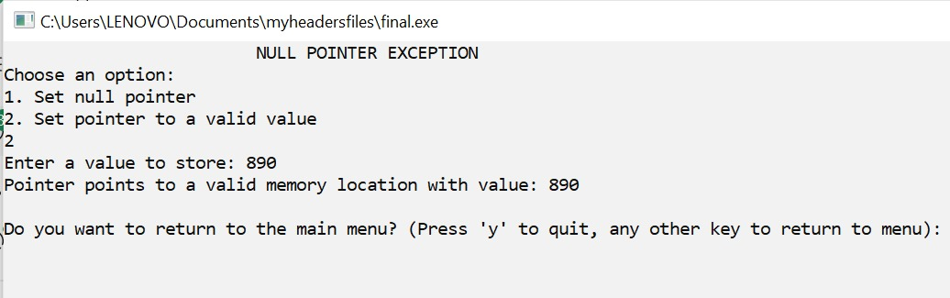
User trying to dereference valid pointer:

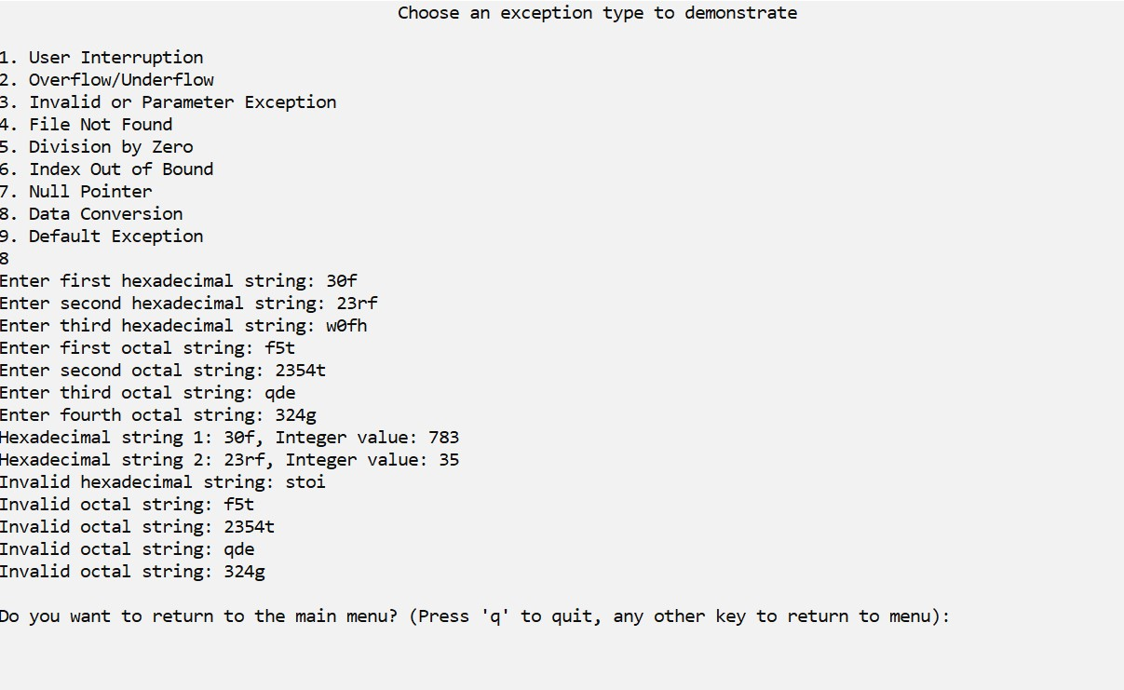
DATA CONVERSION EXCEPTION

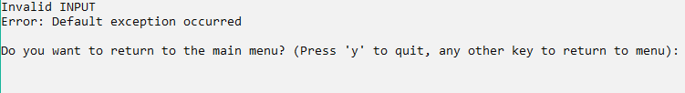
DEAFULT EXCEPTION:

